Nexora membership applications and decisions
Document 10 of the Nexora learning guides
Source snapshot 14 October 2026 at 06:41 UTC
Understand application forms, review details, evidence and staff approval or rejection.

Recognise the screen and its scope
Open /membership/applications, /membership/applications/[id]. CRM routes use port 3017; member routes use 3018; public website routes can use 3019. Brackets name a route parameter, not text to paste into a browser. Choose a real record or site id from the application.
This guide covers Personal and company applications; Application details and review summary; Terms quoted rates and submission; Evidence files; Approve and reject decisions; Membership creation and notifications.
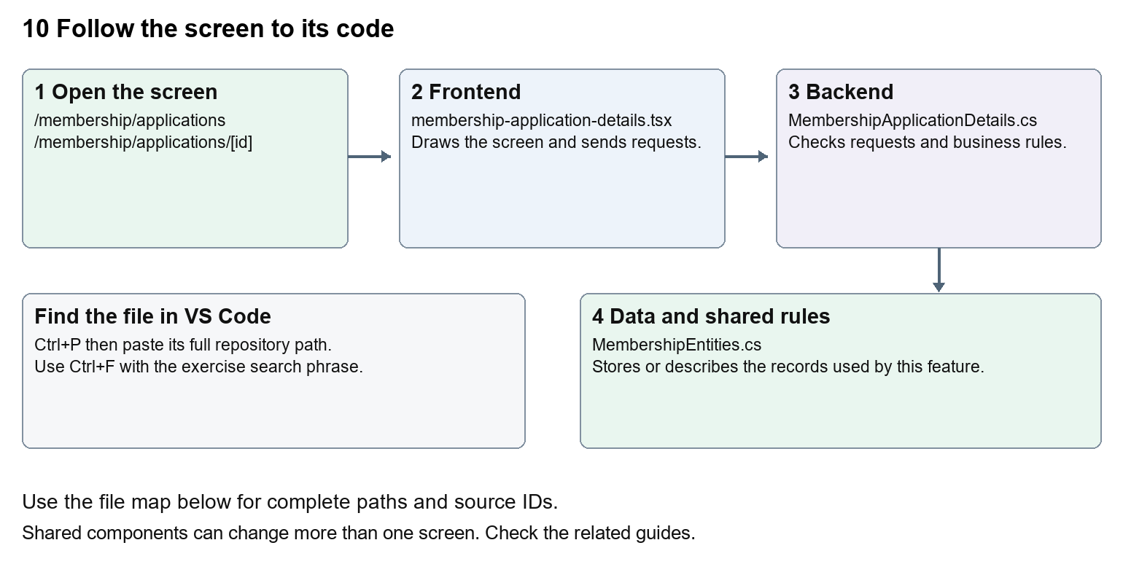
The diagram shows the file roles. The full paths below are what you paste into Ctrl+P.

Find the files in VS Code
Role | File and source ID | What it does
Screen | S0103 membership-application-details.tsx | Main UI or route for this topic
Server | S0506 MembershipApplicationDetails.cs | Endpoints or server rules
Data | S0418 MembershipEntities.cs | Data shape or persistence structure

Screen S0103
apps/web/src/features/membership/membership-application-details.tsx
Server S0506
backend/src/Modules/Nexora.Modules.Membership/MembershipApplicationDetails.cs
Data S0418
backend/src/Modules/Nexora.Modules.Membership/Domain/MembershipEntities.cs
The complete HTML manual opens these source IDs inside its Source library. The Word manual shows short labelled extracts so you can learn the flow before reading large files. Each individual Markdown guide includes its complete primary files after the walkthrough.

Follow the request and the records
1. A staff or member form chooses a permitted product and subject.
2. A saved draft retains editable application details.
3. Submission validates the draft and produces an application record.
4. Staff read the review summary and available clean evidence.
5. An authorised decision calls server rules which record the outcome and any resulting membership.

Read the code with an explanation
Draft, submitted application and active membership are separate states. Client forms help collect information; the application command and service enforce product, account-link and eligibility rules. Review summaries bring related facts together. Evidence scanning controls which attachments may be opened; the presence of an uploaded file does not mean it is safe or approved.
Source reference S0103 apps/web/src/features/membership/membership-application-details.tsx
Selected opening lines with their original numbers. The complete file is in the HTML source library.
0001 "use client";
0002 import { useEffect, useState } from "react";
0003 import { moduleApi } from "../shared/module-api";
0007 type Names = { memberType: string | null; category: string | null; subscriptionBand: string | null; invoicingAccount: string | null };
0008 type Result = { version: string; status: string; lifecyclePurpose: string | null; statusEffectiveOn: string | null; details: ApplicationRequestedDetails; names: Names };
0009 type Choice = { id: string; name: string };

The import lines lead to shared components and helpers. Start at the exported component or route function; follow the request helper to the server rather than assuming the whole feature lives in this file.
Source reference S0506 backend/src/Modules/Nexora.Modules.Membership/MembershipApplicationDetails.cs
Extract from source line 21. A fragment from a long line is shown without the rest of that line.
0021 api.MapGet("/applications/{id:guid}/details", async (Guid id, MembershipDbContext db, CancellationToken ct) =>

On the server, look for MapGet to load records, MapPost to create or perform an action, MapPut or MapPatch to change data, and RequireAuthorization for permissions. Some shared methods register endpoints indirectly. Find SaveChangesAsync to see the database write. A request method alone does not tell you every side effect.
Source reference S0418 backend/src/Modules/Nexora.Modules.Membership/Domain/MembershipEntities.cs
Selected opening lines with their original numbers. The complete file is in the HTML source library.
0001 using Nexora.BuildingBlocks.Domain;
0002 namespace Nexora.Modules.Membership.Domain;
0003 public sealed class MembershipProduct : TenantEntity
0004 {
0005 public string Name { get; set; } = "";
0006 public string Category { get; set; } = "";

Follow model fields to their request names and database mapping. An id points to a particular record. A tenant id limits the organisation. A version or concurrency stamp protects newer edits. Some model files describe contracts rather than tables; check the owning DbContext before assuming storage.

Make or trace your first change
1. Press Ctrl+P and open apps/web/src/features/membership/membership-application-details.tsx.
2. Press Ctrl+F and search for export function. In this snapshot it appears at line 12.
3. Read-only exercise: locate the application detail component, identify its request path and expected version, then find the corresponding C# endpoint. Sketch the difference between saving details and deciding an application.
4. Record the file, request path and server handler you found. This exercise is read-only; no stored records need to change.
Extract from source line 12. A fragment from a long line is shown without the rest of that line.
0012 export function ApplicationRequestedFields({ value, onChange

These exercises have not been applied to the application. Their search phrases are verified against the captured source. Line numbers can move; the phrase and file path are your main navigation aids.

Check a change and diagnose problems
Confirm the original screen still loads, the changed words appear in the intended place, and another screen using the same component still behaves correctly. If an action fails, inspect the browser Network response, the relevant helper and server validation message. Use the common error table at the beginning of the manual. Reload on a version conflict instead of removing the version check.
A syntax error after a text edit usually means a quote, brace or closing tag changed. Compare your diff with the original. An unchanged browser result can mean the wrong port, a saved published configuration overriding a default, or a running API that has not reloaded.

Understand the current limits
membership.manage and membership.decide are separate rights. Approval can create real records and notifications. Notification queue or inbox state does not prove external email delivery.

Continue learning
Related guides 09 Nexora member records and subscriptions, 11 Nexora membership setup and products, 24 Nexora member portal login and onboarding, 25 Nexora member portal journeys, 29 Nexora documents evidence and file safety.

